ACTIVITY 3 WRITING & PRESENTING

3.1 What did you learn?
Complete the sentences, by underlining the correct word.

- Person who sends the message must be (old / clear).

- Important to understand the message, before (sending / responding) on it.

- Use (negative / positive) body language

- There is (more / less) than one way to communicate – verbal and non-verbal

- A message can (slowly / quickly) be understood wrong.

3.2 What is communication?

Fill in the correct word. Choose from the word box.

a) Communication is a two-way process
b) There is a sender (the person sending the
information) and a receiver (the person
receiving the information).
c) It is as if we talk in code and the receiver has to decode the message before he can understand it.
d) We respond based on what we think we have heard, our beliefs and our background

3.3 When we communicate we use the following:
words
body language
tone of voice
3.4 Name the 6 signs of positive body language.
- Making eye contact
- Keeping our hands open as opposed to clenched
- Smiling
- Standing up straight
- Leaning towards the person we are listening to
- Turning our head slightly towards the person talking.

ACTIVITY 4 LANGUAGE STRUCTURE & CONVENTIONS

1. This is my school bag.
2. That car across the road is red.
3. I love this banana milkshake.
4. Look at that monkey in the tree.
5. Wash this spoon before you dry that plate.
6. That boy next to the tree is my brother.
7. This is my new dog.

4.2 Plural: these and those
1. These are my cats.
2. At night those stars look like tiny spots of light.
3. I received these new shoes for my birthday.
4. Those birds are flying away.
5. I like these pancakes.
6. Those learners on the playground are noisy.

ACTIVITY 5 LISTENING & SPEAKING

Complete the table: Body language

Positive signals |  | Negative signals
Signal | Meaning | Signal | Meaning
Leaning forward | interest | Crossed arms | defensive
Smiling | friendly | Fidgeting | nervous or bored
Nodding | attentive & alert | Lack of  eye contact | untrustworthy
Eye contact | curious & focused | Leaning back | discomfort

ACTIVITY 7 WRITING & PRESENTING
List eight body language mistakes one can make in an interview.
1. Slouching
2. Breaking eye contact
3. Pointing
4. Crossed arms
5. Fidgeting
6. Hands behind your back
7. Shifty eyes
8. Staring

ACTIVITY 8 LANGUAGE STRUCTURE & CONVENTIONS
- These are my pencils.
- Those are my mother’s pencils
- These flowers are beautiful
- Those flowers are dead.
5 These apples are green.
6. Those apples are red.

ACTIVITY 9 LISTENING & SPEAKING

Body Language
First look at the demonstration of the teacher and learners having an interview and then complete the following questions by filling in true or false.

- The teacher kept her eyes focused on the learners. YES

- The teacher’s arms were nicely (not crossed) on her lap. NO

- The teacher kept her hands still. NO

- The teacher walked in with her hands next to her body. NO

- The teacher used the right facial expressions. YES

- The teacher nodded her head when she agreed to something. YES

- The teacher sat up straight. NO

8. Do you think the teacher is ready for an interview?
Tick the correct reason.
√
No, the teacher’s body language is incorrect. She must still practice.
Yes, the teacher’s body language is correct.

ACTIVITY 10 READING & VIEWING / WRITING & PRESENTING
Match the body language to the correct meaning

Body Language | Answer | Meaning
a) Brisk, erect walk | 7 | 1. Defensiveness
b) Standing with hands on hips | 10 | 2. Rejection, doubt, lying
c) Arms crossed on chest | 1 | 3. Anger, frustration, apprehension
d) Touching, slightly rubbing nose | 2 | 4. Anticipation
e) Hand to cheek | 9 | 5. Insecurity, nervousness
f) Hands clasped behind back | 3 | 6. Impatience
g) Rubbing hands | 4 | 7. Confidence
h) Tapping or drumming fingers | 6 | 8. Authoritative
i) Biting nails | 5 | 9. Evaluation, thinking
j) Steeping fingers | 8 | 10. Readiness, aggression

ACTIVITY 11 LANGUAGE STRUCTURE & CONVENTIONS
Fill in “the”
1. Please return the book that you borrowed from me.
2. I like the red flowers in my garden.
3. She wore the green dress for her interview.
Indefinite article (a and an)
Fill in ‘a’ or ‘an’
1. I brought a banana to school.
2. Bring an umbrella, it’s going to rain.
3. He needs a ruler in class.
4. Mother said an apple a day keeps the doctor away.
ACTIVITY 12 LANGUAGE STRUCTURE & CONVENTIONS
Go outside and clean your feet. | because  but | She wasn’t hurt.
She fell into the drain. | because  but | Clean your shoes.
Please go outside. | because  but | They are dirty.

a) Go outside and clean your feet because they are dirty.
b) She fell into the drain but she wasn’t hurt.

ACTIVITY 15 WRITING & PRESENTING

Write the characteristics of the different communication styles.

Only write C/A/P which represents Child, Adult and Parent

COLUMN A | ANSWER: C / A / P
Reason | A
Playful | C
Condemn | P
Fun | C
Facts | A
Nurture | P
Tantrums | C
Logic | A
Manipulative | C
Always, never | P

Write the correct communication style for each of the following statements:

Only write C/A/P. It represents: Child, Adult and Parent

1 | “A client is expecting the delivery this afternoon at 15:00. Can you please make sure it is done?” | A
2 | “Ah shame, are you not feeling good today?” | P
3 | “Can we discuss this?” | A
4 | “You always expect me to work late!” | C
5 | “How many times have I told you not to be late?” | P
6 | “You are ignoring a colleague.” | C
7 | “I am unable to help you when you are interrupting me.” | A
8 | “Can you explain why you are late?” | A
9 | “You look tired, why do you not sit down?” | P
10 | Said in a sarcastic way: “Oh, I see you have not done your work!” | C

ACTIVITY 16 LANGUGE STRUCTURE & CONVENTIONS
Fill in: the. a or an
1) The dog my father bought for me is a poodle.
2) The bike that Pablo bought cost him R20 000.
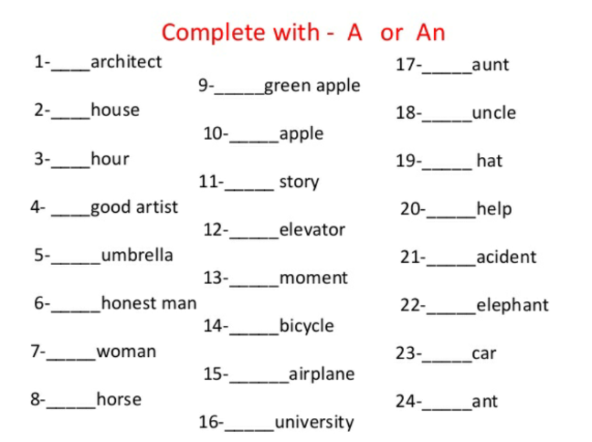
3) The movie we saw last night was very funny.

ACTIVITY 18 REVISION TEST
SECTION A: READING COMPREHENSION
QUESTION 1
TEXT A: INFORMATION TEXT
1) Why is communication a two-way-process? (2)
Communication is a two way process because when we communicate, we have a sender (the person communicating) and the receiver (the person receiving the information).
2) Name three things we use when communicating. (3)
We use words, body language and tone of voice when we communicate.
3) Circle the correct word in brackets. (1)
Words make up the (smallest / biggest) part of communication.
4) How would you describe the body language in the following pictures? (2)
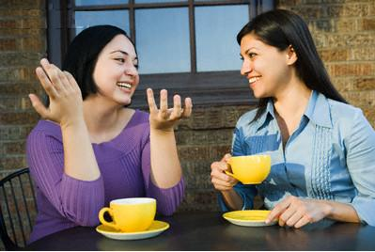

friendly / happy / open


sad / disappointed / unhappy

5) Why is the tone of your voice such an important part of communication? (1)
Tone is very important in determining the real message.

6) Give one example of positive body language. (1)
Any one of the following.
- Making eye contact
- Keeping our hands open as opposed to clenched
- Smiling
- Standing up straight
- Leaning towards the person we are listening to
- Turning our head slightly towards the person talking.

TOTAL QUESTION 1: (10)

SECTION B: LANGUAGE
QUESTION 2
TEXT B: INFORMATION TEXT
2.1) Fil in: the, a or an (3)
- We can communicate from an adult or a parent ego state.
- “Hey you with the dirty feet!”

2.2) Choose the correct conjunction and join the two sentences to make a compound sentence. Write the sentences on the lines.

Go outside and clean your feet. | because  but | She wasn’t hurt.
She fell into the drain. | because  but | Clean your shoes.
Please go outside. | because  but | They are dirty.

a) Go outside and clean your feet because they are dirty. (2)
One mark for correct sentence structure. One mark for correct punctuation
b) She fell into the drain but she wasn’t hurt. (2)
2.3) Find one question sentence in the information text and write it down. (1)
Remember when your mother just cleaned the kitchen floor and you came running in with muddy feet?

2.4) Find the compound word in line 5 and write it down. (1)
outside

2.5) Circle the correct word in brackets. (2)
- (This / That) car opposite the street belongs to (mine / me).
2.6) Find the two verbs (doing words) in line 4 and write it down. (2)
cleaned and running
2.7) Rewrite the following and put in the missing capital letters and punctuation. (7)
You felt hurt because it was not on purpose and you pushed out your lip saying: “ It’s not my fault. ”
TOTAL QUESTION 2: (20÷2=10)
SECTION C: VISUAL LITERACY
QUESTION 3
3.1 Refer to the cartoon and list the three states of communication with (6) examples from the cartoon.
Parent state: “Hey , you with the dirty feet, outside!”
Child state: “It’s not my fault.”
Adult state: “I have just washed the floor and your feet are dirty. Please go outside and clean them before you come in.”
3.2 Read the following cartoons and say if the situations are (4)
Assertive / Non-Assertive or Aggressive.
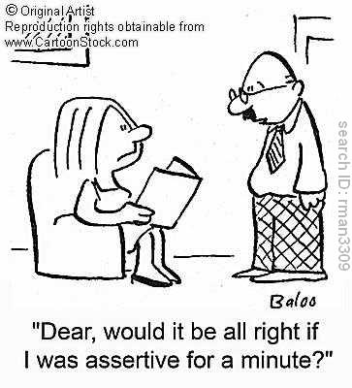
The husband is
Non-Assertive

because he asks his wife’s permission to be assertive.

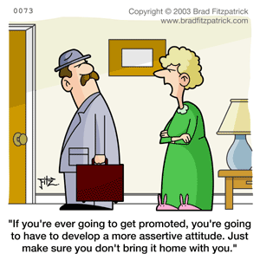
The wife is Aggressive
because she gives her husband an order which clearly states that he is not OK.

The girl is Non-Assertive

The woman is
Assertive
because she expresses what she thinks and feel in a positive way.

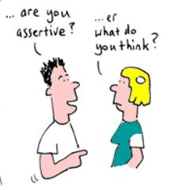

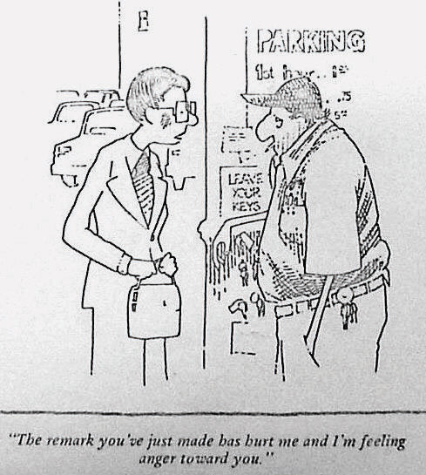

TOTAL QUESTION 3: (10)
The remark you’ve just made has hurt me and I’m feeling anger toward you.

SECTION D:
QUESTION 4
Answer the questions.

1) What is the topic of this text? (1)
ladybugs
2) There are lots of detail you can learn about ladybugs from reading (1) this text. What do the details tell you about ladybugs?
The details tell you more about what the ladybugs look like.
3) What’s the main idea of this text? (1)
The main idea is Ladybugs are colourful beetles.
4) What does the author say about most ladybugs? (1)
Most ladybugs have red wings with black spots.
5) What does the author say about some ladybugs? (1)
Some ladybugs have orange or yellow wings.

TOTAL QUESTION 4: (5X2=10)

